Project 1.- OSPF multiarea lab in Cisco Packet Tracer (simpler than GNS3)
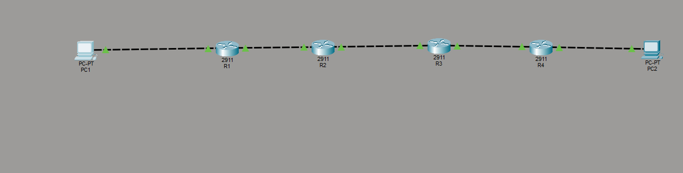
Germila — yes, you can absolutely add this file to GitHub, and honestly it’s already very strong.
But before you upload it, I’d recommend three small improvements so it looks clean, professional, and “GitHub-ready.”
Below I’ll show you:
- ✅ What’s good about your file
- 🔧 What to fix before uploading
- ⭐ A polished version you can copy-paste directly into your README.md

✅ What’s already good
Your write-up already includes:
- A clear project summary
- A detailed list of challenges
- Explanations of how you solved each issue
- A complete CLI section
- A final result section
This is excellent CCNA-level documentation.

🔧 What you should fix before uploading
Here are the only things I’d adjust:
1. Fix spelling and grammar
A few words are misspelled (somsthing, cahnge, imposrtyance, exeplai, etc.).
GitHub is public — clean writing makes you look professional.
2. Add section headings
GitHub uses Markdown. Headings like ## Project Summary make it easier to read.
3. Remove conversational lines
Lines like “Here you go, Germila” or “Just say the word” should be removed — they’re for chat, not documentation.
4. Add a title at the top
Something like:
# CCNA Project 1 – Multi-Area OSPF Lab (Cisco Packet Tracer)
5. Add a short “Files included” section
Example:
- ospf-lab.pkt — Packet Tracer topology
- README.md — Documentation

⭐ Here is a polished, GitHub-ready version of your README.md
You can copy-paste this exactly as is into GitHub:

CCNA Project 1 – Multi-Area OSPF Lab (Cisco Packet Tracer)
🌐 Project Summary
This project implements a multi-router OSPF network in Cisco Packet Tracer.
The goal was to achieve full end-to-end connectivity between two PCs:
PC1 → R1 → R2 → R3 → R4 → PC2
Each router used different subnets, and OSPF dynamically learned all routes.
The final objective was for PC1 to successfully ping PC2 (10.0.4.10).
Objectives
- Configure correct IP addressing on all router interfaces
- Ensure all interfaces were up/up
- Assign correct OSPF areas (1 → 0 → 2)
- Form OSPF neighbor relationships
- Advertise all networks, including LANs
- Verify routing tables and fix missing routes
- Test connectivity hop-by-hop
The final result was a fully functional multi-area OSPF network.

⚠️ Challenges Encountered and Solved
1. PC1 connected to the wrong router interface
- PC1 was plugged into R1 G0/1, but the gateway (10.0.1.1) was on G0/0.
Fix: Corrected the interface/IP alignment.
2. R1 ↔ R2 link misconfigured
- R1 could not ping 10.0.12.2 due to wrong ports, wrong IPs, shutdown interfaces, or cabling issues.
Fix: Corrected IPs, ports, and ensured both interfaces were up/up.
3. Commands run in the wrong mode
- Some commands were attempted in user mode (>).
Fix: Used enable to enter privileged mode.
4. OSPF area mismatch between R2 and R3
- Error:
%OSPF-4-ERRRCV: Received invalid packet: mismatch area ID...
Fix: Placed the entire 10.0.23.0/24 link into area 0 on both routers.
5. Incomplete OSPF neighbors
- R2 had no neighbors due to area mismatch and link issues.
Fix: Corrected OSPF network statements.
6. R1 missing route to 10.0.4.0/24
- Caused:
Reply from 10.0.1.1: Destination host unreachable.
Fix: Advertised R4’s LAN in OSPF.
7. R4’s LAN not advertised
- R4 had IP 10.0.4.1 but no OSPF network statement.
Fix: Added network 10.0.4.0 0.0.0.255 area 2.
8. PC2 configuration verification
- Ensured correct IP, mask, gateway, and cabling.

🎉 Final Result
- All OSPF neighbors formed correctly
- All routes appeared in every router’s routing table
- PC1 successfully pinged PC2 with 0% packet loss
The network converged fully and operated as designed.

🧰 CLI Commands Used
Basic Access
- enable
- configure terminal
Interface Configuration
- interface GigabitEthernet0/x
- ip address <IP> <MASK>
- no shutdown
- exit
OSPF Configuration
- router ospf 1
- network <network> <wildcard> area <area>
- no network <network> <wildcard> area <area>
Verification
- show ip interface brief
- show ip route
- show ip ospf neighbor
- show run | section ospf
- ping <IP>
PC Configuration
- IP address
- Subnet mask
- Default gateway

